Year 11 Mathematics Specialist

2018 Revision Assignment 1

**In Class**

***Instructions:*** *to be completed at home, Calculators are permitted*

**SHOW ALL WORKING**

Time Allocation: 50 minutes

Name: _______________ Total Marks: 40 marks

1. (5 marks: 3,2)

80 students were asked in a survey if they had previously broken their leg and/or broken their arm. Information from the survey indicated that 30% of students had broken arms, one quarter of those surveyed had suffered broken legs and 30% had not previously broken an arm of leg. How many students had:

1. Broken an arm and a leg?
2. Broken an arm, but not a leg
3. (12 marks: 1, 3, 2, 3, 3)

A committee of 7 people are to be selected from 8 Labor, 6 Liberal and 3 Green politicians. How many different ways can the committee be selected if:

1. There are no restriction
2. All three political parties are equally represented
3. There are two Green representatives
4. The liberal representatives are in the majority
5. A husband and wife pair, Alex and Alice, cannot be in the same committee
6. (7 marks: 1, 2, 1, 3)

Particle **F** starts moving from the point with the position vector 6**i**+10**j** meters with a velocity 4**i**-6**j** meters per second.

1. Determine the position vector of **F** after 3 seconds.
2. Find the distance from **F** to the point with the position vector -4**i**+2**j** after 3 seconds
3. Determine the position vector of **F** after ***t*** seconds
4. Find when **F** is the closest to the origin and state this distance
5. (5 marks: 3, 2)

OABC is a parallelogram with OA parallel and congruent to CB. The point F divides AB in the ratio 2:1. OF extended meets CB extended at E

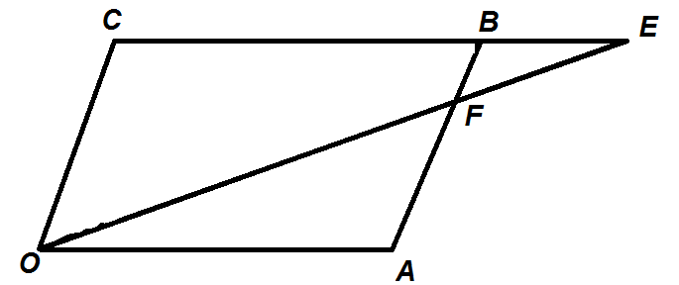

1. Prove that ∆FOA and ∆FEB are similar
2. Hence, deduce that F divides OE in the ratio 2:1.
3. (3 marks)

Expand and simplify

1. (**m-n**)**.**(**m**-**n**)
2. (**c**+**d**)**.**(**c**+**d**)
3. (**m**-4**n**)**.**(3**m**-**n**)
4. (8 Marks: 2, 1, 1, 4)

Given that $a=-4i+12j and b=10i-8j$**,** find:

$\left|a+b\right|$

1. The unit vector parallel to $a+b$
2. A vector that is parallel to $a+b$**,** but with a magnitude of 10
3. $a$ in terms of $p and q$ where $p=2i+j$ and $q=-3i+2j$

**End of task**